T4 Bridgeplate Test Cable

The intent of this able

Parts list

* 1 Weidmeuler plug
  + Manu pn# 1418100000
  + Trimet pn xxxxxx
* 14 weidmuler pin
  + Trimet PN# xxxxxxxxxxxx
  + Manu pn 1427600000
* BP side plug
  + Spacecraft SCPBH08PIVG22-14S-F0(U297)
* 16 #16 socket pins Tri-Met PN#245-2112X
* 16 wire labels cut in half
* ¾ spiral wrap, or Raytech DR-25 - 12-13 ft
  + https://www.digikey.com/en/products/detail/te-connectivity-raychem-cable-protection/DR-25-TW-3-4-0-SP/5317580
  + https://www.digikey.com/en/products/detail/te-connectivity-aerospace-defense-and-marine/DR-25-3-4-0-SP/2397038
* 14-16 ft 16GA tefzel wire, do not use exane wire, its insulation is twice as thick.

Tools needed

* DMC AF8
* Pin pusher
* Pin installer pliars 11-7345

Order of assembly

1. Pull wire, 14 wires at roughly 14 ft long
2. Cut wires to length
3. Label each wire 6 inches back from the end
4. Terminate the weidmuler plug
5. Find a T4 and hang the wire from a bridge plate plug. Zip tie the cable with the U-bend. Use 2 zip ties. Add pic or diagram of setting the cable hang
6. Wrap the cable from the weidmuler end with the spiral wrap. Stop 14 inches from the bp end of the cable. Leave enough wrap to finish just past the plug.
7. Disassemble the spacecraft bp plug and run the conduit adapter, o-ring, 90\* elbow and the plastic ring down the cable.
8. Cut the wires even with each other
9. Run the proper cables through the outer rubber grommet
10. Terminate the wires with the #16 socket pins with the DMC AF8 crimper set on 16GA wire
11. insert the wires in their respective holes.
12. Run the outer rubber grommet down and then assemble the plug
13. Run the rest of the spiral wrap down the harness
14. Profit!!!!

Pinout:

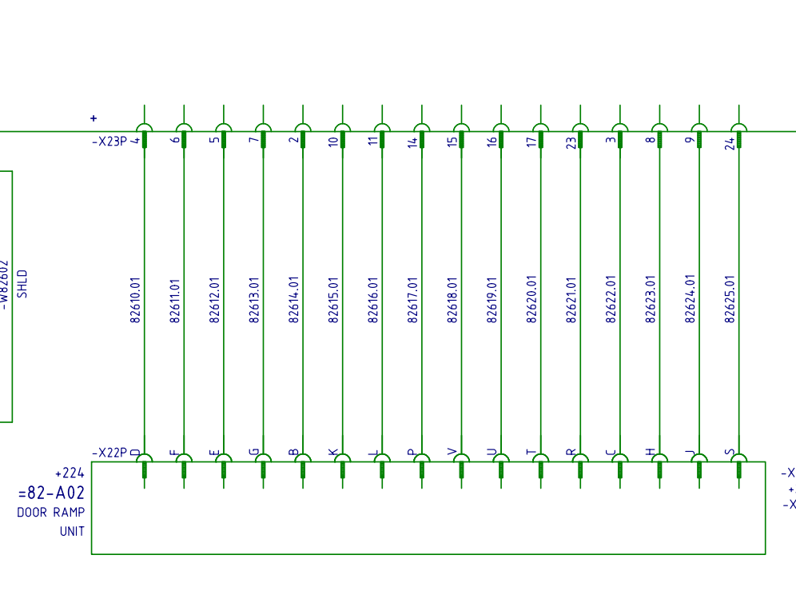

Figure 1: wire schematic

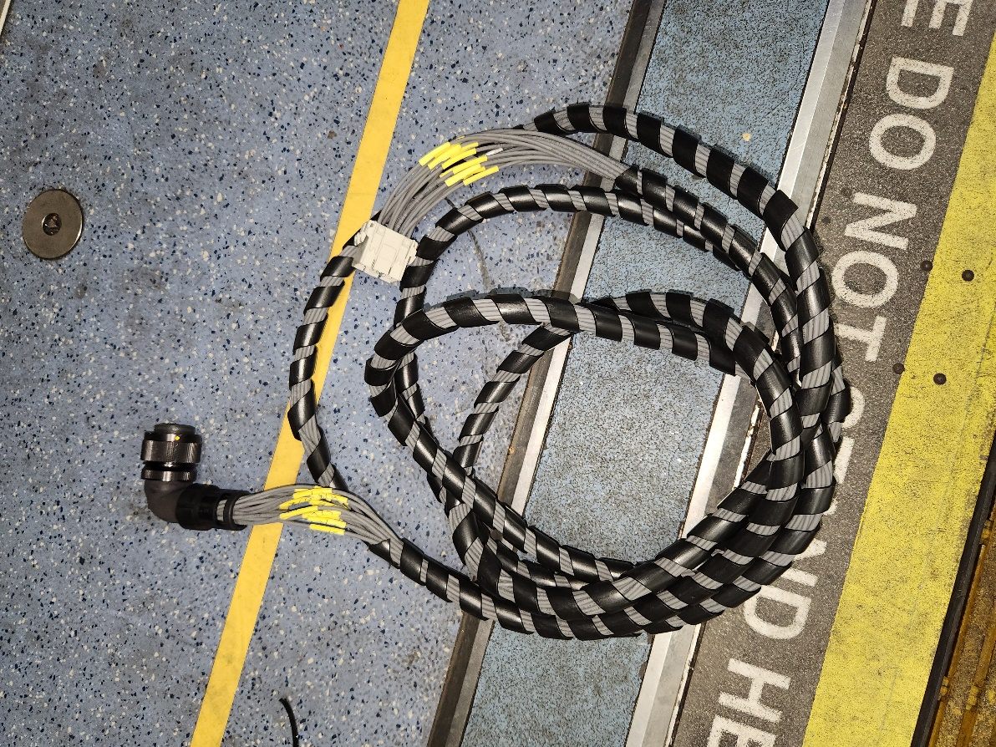

Figure 2: finished product using exane wire